## Project to encourage breeding of Dalmatian Pelican (*Pelecanus crispus*) at the Evros Delta.

## The Dalmatian Pelican at the Evros Delta

The Dalmatian Pelican is a common bird in Greece. It nests at three sites: Lake Mikri Prespa, Lake Kerkini and Amvrakikos. After the breeding period and during the winter, birds are dispersed all over Greece, even in Turkey. The subpopulation of SE Europe holds 4350 to 4800 birds, while the global population is estimated to 10400 to 13800 birds (Wetlands International, 2006).

The Dalmatian Pelican is one of the criteria species of the Evros Delta SPA (GR1110006). It is observed during the whole year. It is characterized as Vulnerable in Greece and worldwide (Legakis A., Maragou P., 2009), so Evros Delta is of great importance for the species. A maximum of 848 birds was counted during 1996 IWRB MC, so at the Evros Delta almost a 10% of the global population or a 20% of the SE European subpopulation was counted.

Until 1962, 40-50 pairs were still nesting at the Evros Delta but this colony was destroyed by local fishermen (Bauer W., Muller G., 1969). Up to now, there is no record of reproduction at the wetland.

|  |  |
| --- | --- |
| ***Pelecanus crispus*** | |
| IUCN Red list category: | VU |
| Greek Red list category: | VU |
| 1% minimum of European overwintering subpopulation: | 9 |
| Presence in Evros Delta: | P, w |
| Criteria Species: | Yes |

Table 1: Type of presence, protection and data for Dalmatian Pelican at the Evros Delta where VU is Vulnerable, P is Passage and w is overwintering (Ioannidis P., Makrygianni E., Fakriadis Y., 2012).

Graph 1: Variance, mean and monthly presence of Dalmatians Pelicans at the Evros Delta. (Ioannidis P., Makrygianni E., Fakriadis Y., 2012).



|  |  |  |  |
| --- | --- | --- | --- |
|  | Variance for September 2006 to June 2010 |  | Maximum monthly count 2010/11 |
|  | Average of bird counts for September 2006 to June 2010 |  |  |

It is obvious from graph 1 that Dalmatian Pelicans are present almost all the year in Evros Delta. During September and October there is an increase in the numbers, because that time the species leaves nesting areas. Except for the abundance of adult birds there are also numerous young birds that constitute these increased counts. During winter, the number of birds seems to be stable around 100 to 200, followed by a decrease during April – June.

The Dalmatian Pelicans are observed at a variety of biotopes in the wetland. They can be observed feeding or swimming in lagoons, canals, shallow coastal areas and the river Evros. Particularly, after the hydrological restoration of Drana lagoon, they often use the surrounding area for feeding.

**Encourage the reproduction of Dalmatian Pelicans at the Evros Delta**

Recent years’ monitoring of the Dalmatian Pelican by the Evros Delta Management Authority indicates that an effort could be made to encourage birds to start breeding again in the area. This can be supported by the fact that:

* The presence of species in the wetland is stable. The trend of the Greek population is positive and it looks that there is an increase in breeding colonies.
* The Dalmatian Pelicans used to breed at the Evros Delta in the past
* The conditions are favourable, as there are both safe from disturbance places and plenty of food.

Drana lagoon seems to be the most appropriate area for encouraging Dalmatian Palicans’ reproduction, because of lack of disturbance from fishermen and animal breeders. At the same time, the area is frequently patrolled by the Management Authority while after the restoration of Drana lagoon there is plenty of food for the species.

This project will be implemented by the Management Authority in collaboration with the NGO Birdwing (they firstly proposed this project), that are going to fund possible construction of platforms (artificial islets for reproduction).

## BIBLIOGRAPHY

* Legakis A., Maragou P., 2009, The Red Book of endangered animals of Greece, Hellenic Zoological Society, Athens
* Bauer W., Muller G., 1969, Zur Avifauna des Ewros-Delta. Beitr. Naturkd. Forsch. SW – Deutschl. 28:33-52
* Ioannidis P., Makrygianni E., Fakriadis Y., 2012, Monitoring plan for Ornithofauna of Evros Delta: Part B, Analysis of data for target species, Evros Delta Management Authority
* Wetlands International, 2006, Waterbird Population Estimates – Fourth Edition, Wetlands International, Wageningen, The Netherlands

Below, the proposal from Birdwing and the Action Plan for encouraging breeding of Dalmatian Pelicans at the Evros Delta is presented.



**Proposal to encourage breeding of Dalmatian Pelicans (*Pelicanus crispus)* at the Evros Delta**

**Background:**

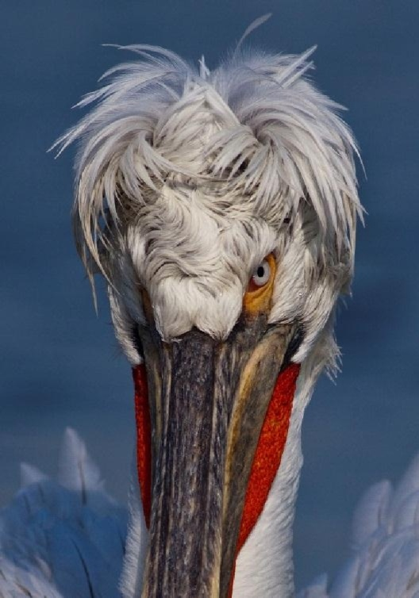

Dalmatian Pelicans start to breed in late March or April usually in dense colonies of up to 250 pairs. They are very sensitive to disturbance and, because they are one of the few bird species to incubate the eggs with the soles of their feet rather than the breast feathers, any sudden departure from the nest can result in lost and broken eggs. Thus one of the most important factors for successful breeding is lack of disturbance. Adults form monogamous pair bonds and depart from the colonies between the end of July and September, although a few remain until November. They are gregarious during the winter, often occurring in large flocks and foraging communally and cooperatively in small groups. The birds return to their breeding sites in late-January to April, depending on the region. Immature birds and non-breeders may remain in the wintering grounds year round.

**Breeding Habitat** They breed on small islands in freshwater lakes or in dense aquaticvegetation such as reedbeds of *Typha* and *Phragmites*. A few breed in Mediterranean coastal lagoons. The species makes use of habitats surrounding its breeding sites, including nearby islands and wetlands.

**Diet** They feed almost entirely on fish, especially carp *Cyprinus carpio*, perch *Perca fluviatilis,* rudd *scardinius erythrophthalmus*, roach *Rutilus rutilus*, and pike *Esox lucius* infreshwater wetlands, and eels, mullet, gobies and shrimps in brackish waters.

**Breeding site** Most nests are situated amongst aquatic vegetation on floating or stationaryislands isolated from the mainland to avoid mammalian predators. They are occasionally built on open ground. Nests usually consist of a pile of reeds, grass and sticks approximately 1m high and 0.5-1.5m in diameter. They often trample the vegetation between nests, and do not tend to nest in areas where such activities would generate deep mud. The trampling activity damages the islands and therefore limits the number of years for which an island can be used for breeding. On average sites in Greece were found to be used for three years in succession. Artificial islands have proved successful as breeding sites in the past, such as those at Kerkini. Where platforms are used, fresh reeds must be made available each year for nesting material.

(Data drawn from www.birdlife.org. See:  [www.birdlife.org/datazone/speciesfactsheet.php?id=3811](http://www.birdlife.org/datazone/speciesfactsheet.php?id=3811))

**Current situation at the Evros Delta:**

Dalmatian Pelicans are found at the Evros Delta at all times of the year outside the breeding season. The delta has plenty of fish available as shown by it being chosen as a wintering area and it is believed that Dalmatian Pelicans have bred in the past.

Dalmatian Pelicans require a suitable site for breeding that:

* is free from disturbance from man (one of the most vital factors)
* is located where other land predators cannot easily reach
* has sufficient nesting material such as reed (*Typha* or *Phragmites*) nearby to cover the breeding area.

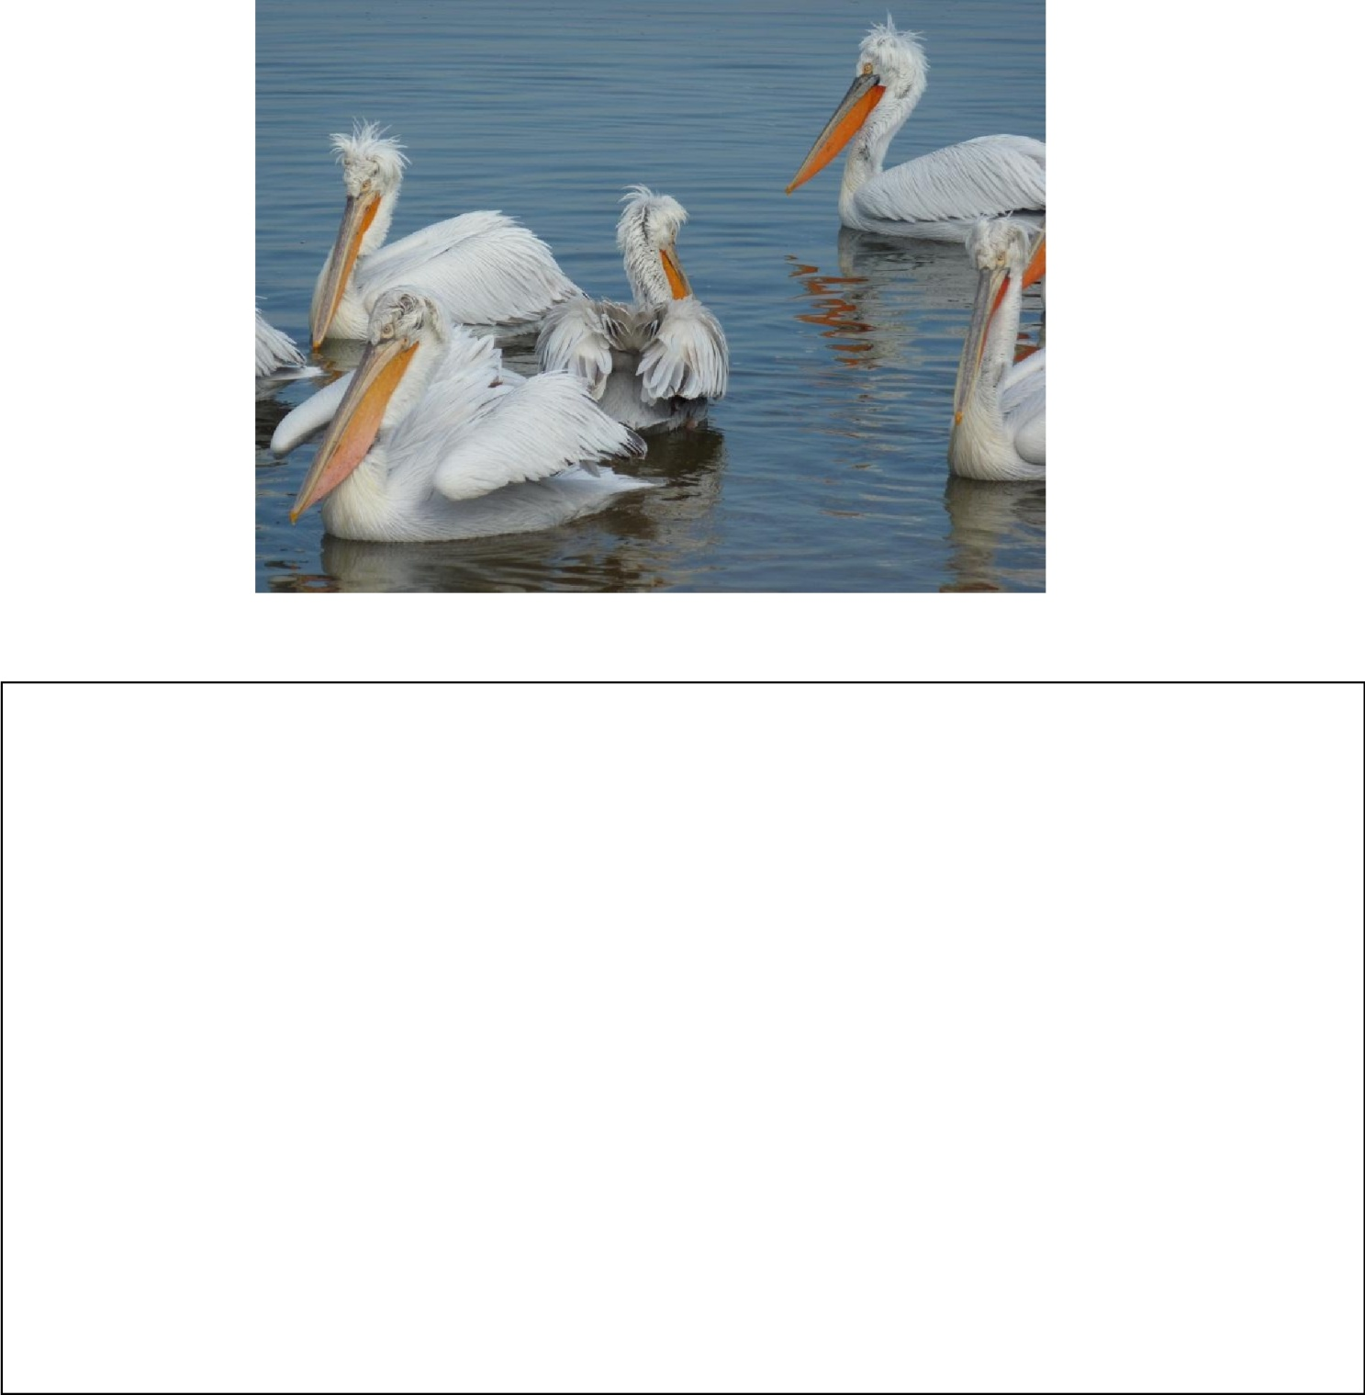

**Summary of proposed phases of the programme**

Phase One of the programme is to determine whether an area or areas within Drana Lagoon is suitable for breeding and to:

* clear part of an existing island
* provide reed material
* monitor the interest shown by the pelicans towards this location
* evaluate whether a platform could be built and used with greater success

Phase Two of the programme is to implement and build a platform. This will be enacted:

* if interest is shown in the breeding site
* if breeding is attempted without success
* if, following evaluation, it is determined that a platform would improve the likelihood of success

**Location for Phase One:**

In May 2012 an island in Drana Lagoon was identified as a possible site for Phase One. Drana is relatively undisturbed by humans and should be made more secure by preventing access by boat through the drainage channel exit. It has several islands of different sizes and one of these (island A on the map) is a place where the Dalmatian Pelicans roost when they are present on the Delta, outside the breeding period.

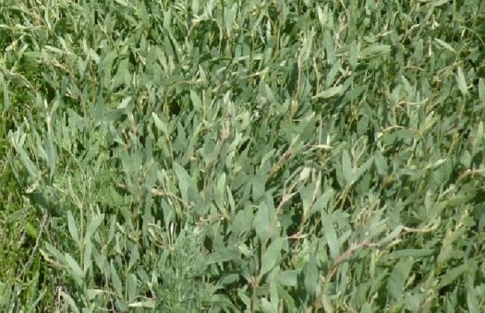

Island A is covered with dense vegetation up to 50cm in height (see pictures) and has no reeds or materials suitable for the nest material. As the size of island A is quite large, the area of the proposed nest site has been chosen at the point marked on the map. The prevailing wind direction makes this location beneficial and is close to their roosting sites. It is over 500m from the nearest road/track.

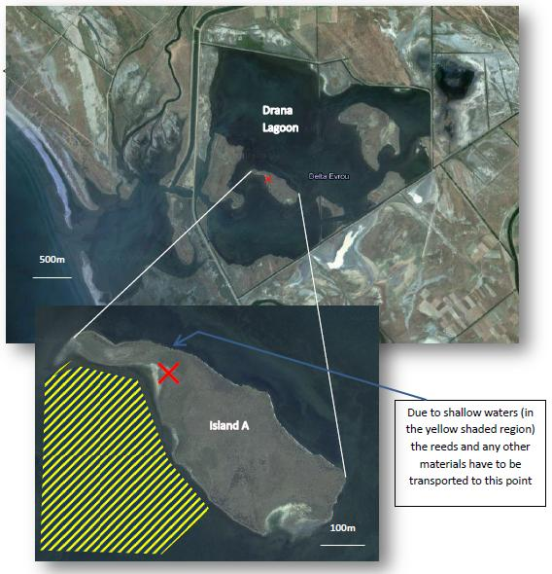

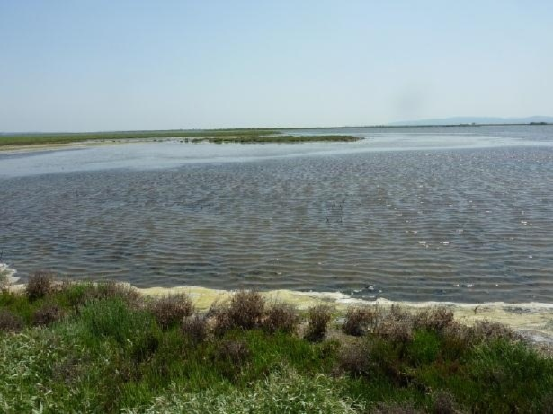

If possible during Phase One a second smaller island, if a suitable one can be found, could also be prepared with the reed materials to test whether the size of island A is too large to feel safe as a site for the pelicans. This will be dependent on water-levels and assessment in the winter months.

|  |  |  |
| --- | --- | --- |
| **Programme Timetable:** | |  |
| Phase One | **Timescale: May 2012 – June 2013** | |
|  |  |  |
| May 2012 |  | Evaluate and choose suitable site for Phase One |
| November/December 2012 | | Clear area of vegetation (approximately 6m x 6m) |
| December2012 |  | Cut reeds from another area of the delta and transport reeds to island A and cover the cleared area with them |
|  |  |  |
| January to June 2013 | | Monitoring breeding interest |
| Phase Two | **Timescale: Autumn 2013 - Summer 2014** | |
|  |  |  |
| Autumn 2013 |  | Produce an evaluation report outlining how Phase Two should be enacted |
|  |  |  |
| November/December 2013 | | Constructing and siting wooden platform |
| January to June 2014 | | Monitoring breeding interest |